W
e are always very busy at Kincraig and I have listed below all the visits and visitors we have had in school since September 2017…

- Life Education Bus – Whole School
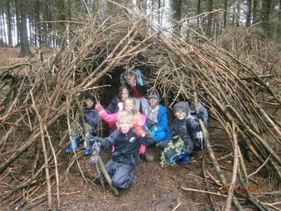
- Y3 – Dinosaurs in the Wild - Manchester
- School’s Alive performance at the Grand Theatre Y3 - 6
- Y6 – Synagogue visit
- Y2, Y3, Y5 – Cinema
- Football team played against other schools
- Netball team played against other schools
- Cricket team played against other schools
- Y5 & 6 children in writing competition at BFC – 2 winners who had work published
- Y6 card making at Spiral Health Care
- Y5 Jodrell Bank
- Y4 & Y6 Science workshop – Millfield High School
- Climbing wall - All year groups
- Y6 - Scavenger Hunt around Beacon Fell
- Y2 & Y6 – trip to Moor Park Memorial Gardens for Remembrance Day
- Whole School – Remembrance Day Assembly and laying of wreaths and Poppies
- WW2 Workshop at Lancashire Museum – Y6
- Montgomery Remembrance Service – Y6
- British Legion Veteran to talk to Y2 & Y6
- Book fair
- Y1 - Police Canine unit
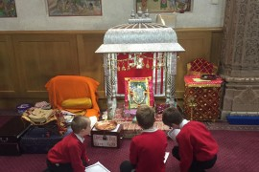
- Y1 - Vets for Pets
- One Million Minutes (Reading initiative by Blackpool Challenge)
- School Photographs
- Shared staff meetings with Blackpool Teaching School Alliance
- Anti-Bullying Ambassadors to Blackpool’s Anti-bullying conference
- Anti-Bullying week activities – Whole School
- Children in Need – Whole School initiative fair to raise money
- School Nurse – Rec, Year 5/6
- Visual Screening tests – Rec
- Hand & Dental hygiene – Rec, Y1, Y2 & Y3
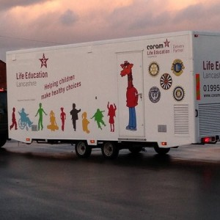
- School Nurse – Y4 & 5 – Hidden Sugars session
- School Nurse – Y1 – Healthy Eating
- Wider Opps – Ukulele lessons – Year 5
- Fire Brigade - Year 2 & 6
- Magistrates – Year 6
- Manchester museum – Y5
- Y6 – Town Hall visit
- Parents reading sessions - Wed AM’s for 45 minutes – Rec & Y1
- Blackpool Schools and Youth Workers – Whole School Assemblies
- Rev Simon Cox – Whole School Assemblies
- Christmas Carol Service with All Hallows Church
- Jungle Book at Blackpool Opera House – Y2
- Walk to School – Whole School
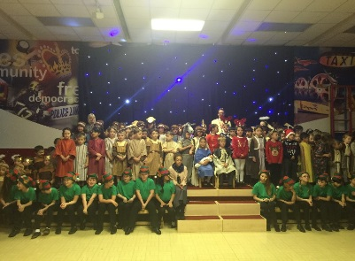
- Hindu Temple – Year 4
- Lancaster museum (Romans) – Year 3
- Bike Ability – Year 5
- Road Safety Crossing Patrol – Year 3
- Nativity Performances – Whole School
- BSYW Christmas Journey – Y1,2 & 3
- PTFA Christmas Fair
- Police/Fire – Year 1
- Football Skills – Years 1, 2 and 3
- Fit to Go for Y4 – Blackpool Football club
- School Choir carol singing at Kilmory Place Day Centre
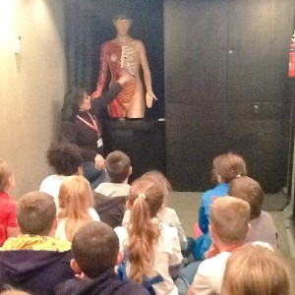
- Science Week and activities
- Parent drop ins by all year groups
- Class assemblies by all year groups
- Fair trade tuck shop
- Chili Children Project
- Reception trip to Holly Farm
- Film night for all children
- Girls & Boys Football matches against other Blackpool Schools
- Easter egg hunt
- Easter Disco for all children
- Easter Bonnet competition
- Y6 visit to Blackpool’s Career fair at Blackpool Tower
- Y6 – High School transition
- Poetry Week
- Street party for Harry & Megan’s marriage
- Sports Day
- Red Nose day – fundraising
- World Book Day – fancy dress
- Seasiders Art Exhibition – selection of children across school
- Bispham Gala – Poster competition
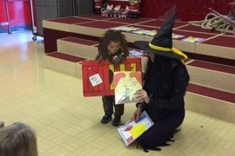
- Local Author Dan Worsley visited school to see KS2 children
- Children’s University graduation
- 100% attendance party at Blackpool Football Club
- Initiative week – Enterprise fair
- Y3 Baptist Tabernacle
- Year 1 - Blackpool tower and circus
- Year 2 – Blackpool Zoo
- Year 3 – Lancaster museum – Vikings
- Year 5 – Lancaster Museum
- Year 6 - Chill factor – Manchester
- Y6 Frankie and Bennies
- Y6 cinema – The Incredibles

